Prime Gaps
# Source: AI Source: Provided by: [Data Path: Persons Table -> ID Column: 1, Name_En Column: Motasem Essam] -> From: [ChatGPT] on [7/13/2026]
A prime gap is the difference between two consecutive prime numbers. Prime gaps measure how far apart neighboring primes are and are one of the central topics in elementary number theory because they help mathematicians understand the distribution of prime numbers.
Prime gaps can be small (such as 2, producing twin primes) or arbitrarily large as numbers grow larger.

Definition
# Source: AI Source: Provided by: [Data Path: Persons Table -> ID Column: 1, Name_En Column: Motasem Essam] -> From: [ChatGPT] on [7/13/2026]
A prime gap is the positive difference between two consecutive prime numbers.
If
$$p_{n}$$
and
$$p_{n+1}$$
are consecutive prime numbers, then the prime gap is
$$g_{n}=p_{n+1}-p_{n}.$$
where
- $p_{n}$= the $n$-th prime number
- $p_{n+1}$= the next consecutive prime
- $g_{n}$= the prime gap

Rules for Prime Gaps

1. A Prime Gap Is Measured Between Consecutive Primes
# Source: AI Source: Provided by: [Data Path: Persons Table -> ID Column: 1, Name_En Column: Motasem Essam] -> From: [ChatGPT] on [7/13/2026]
The two primes must be consecutive.
Example
$$11, 13$$
Gap:
$$13-11=2.$$

2. Prime Gaps Are Positive Integers
# Source: AI Source: Provided by: [Data Path: Persons Table -> ID Column: 1, Name_En Column: Motasem Essam] -> From: [ChatGPT] on [7/13/2026]
Since consecutive primes are distinct and increasing,
$$g_{n}>0.$$

3. Except for the First Gap, Every Prime Gap Is Even
# Source: AI Source: Provided by: [Data Path: Persons Table -> ID Column: 1, Name_En Column: Motasem Essam] -> From: [ChatGPT] on [7/13/2026]
The only even prime is
$$2.$$
After that, every prime is odd.
The difference between two odd numbers is always even.
Example
$$17, 19$$
Gap:
$$2.$$

Example
$$23, 29$$
Gap:
$$6.$$

4. The Smallest Prime Gap Is 1
# Source: AI Source: Provided by: [Data Path: Persons Table -> ID Column: 1, Name_En Column: Motasem Essam] -> From: [ChatGPT] on [7/13/2026]
This occurs only once.
Example
$$2, 3$$
Gap:
$$1.$$

5. The Smallest Repeating Prime Gap Is 2
# Source: AI Source: Provided by: [Data Path: Persons Table -> ID Column: 1, Name_En Column: Motasem Essam] -> From: [ChatGPT] on [7/13/2026]
A gap of
$$2$$
forms a pair of twin primes.
Example
$$29, 31.$$

6. Prime Gaps Can Become Arbitrarily Large
# Source: AI Source: Provided by: [Data Path: Persons Table -> ID Column: 1, Name_En Column: Motasem Essam] -> From: [ChatGPT] on [7/13/2026]
There is no largest prime gap.
As numbers increase, increasingly large gaps occur between consecutive primes.
Example
Between large primes, gaps of dozens, hundreds, or thousands of integers may occur.

7. Large Gaps Do Not Mean Primes Stop Existing
# Source: AI Source: Provided by: [Data Path: Persons Table -> ID Column: 1, Name_En Column: Motasem Essam] -> From: [ChatGPT] on [7/13/2026]
Even after a very large gap, another prime always exists because there are infinitely many prime numbers.

Common Prime Gaps
# Source: AI Source: Provided by: [Data Path: Persons Table -> ID Column: 1, Name_En Column: Motasem Essam] -> From: [ChatGPT] on [7/13/2026]
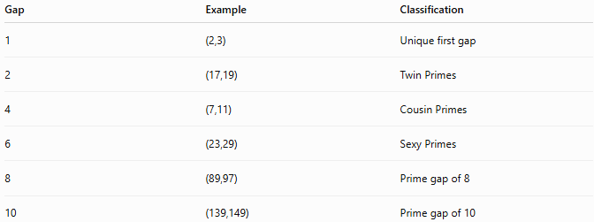
Gap | Example | Classification
1 | (2,3) | Unique first gap
2 | (17,19) | Twin Primes
4 | (7,11) | Cousin Primes
6 | (23,29) | Sexy Primes
8 | (89,97) | Prime gap of 8
10 | (139,149) | Prime gap of 10

Examples
# Source: AI Source: Provided by: [Data Path: Persons Table -> ID Column: 1, Name_En Column: Motasem Essam] -> From: [ChatGPT] on [7/13/2026]
Example 1
Find the prime gap between
$$11$$
and
$$13.$$
Solution
$$13-11=2.$$
Prime gap:
$$2.$$

Example 2
Find the prime gap between
$$29$$
and
$$31.$$
Solution
$$31-29=2.$$
Prime gap:
$$2.$$

Example 3
Find the prime gap between
$$31$$
and
$$37.$$
Solution
$$37-31=6.$$
Prime gap:
$$6.$$

Example 4
Find the prime gap between
$$89$$
and
$$97.$$
Solution
$$97-89=8.$$
Prime gap:
$$8.$$

Example 5
Find the prime gap between
$$139$$
and
$$149.$$
Solution
$$149-139=10.$$
Prime gap:
$$10.$$

Example 6
Find the prime gap between
$$2$$
and
$$3.$$
Solution
$$3-2=1.$$
This is the only prime gap equal to
$$1.$$

How to Find a Prime Gap
# Source: AI Source: Provided by: [Data Path: Persons Table -> ID Column: 1, Name_En Column: Motasem Essam] -> From: [ChatGPT] on [7/13/2026]
- Identify two consecutive prime numbers.
- Subtract the smaller prime from the larger prime.
$$\text{Prime Gap}=\text{Next Prime}-\text{Current Prime}$$
Example
Find the gap between
$$41$$
and
$$43.$$
Solution
$$43-41=2.$$
Prime gap:
$$2.$$

Real-Life Applications
# Source: AI Source: Provided by: [Data Path: Persons Table -> ID Column: 1, Name_En Column: Motasem Essam] -> From: [ChatGPT] on [7/13/2026]
Prime gaps are used in:
- Number theory research
- Prime distribution studies
- Computational mathematics
- Prime-search algorithms
- Cryptography research
- Algorithm optimization
- Mathematical modeling
- Computer science
- Mathematics education
- Theoretical mathematics

Real-Life Examples
# Source: AI Source: Provided by: [Data Path: Persons Table -> ID Column: 1, Name_En Column: Motasem Essam] -> From: [ChatGPT] on [7/13/2026]
1. Prime Number Research
Mathematicians analyze prime gaps to understand how prime numbers are distributed.

2. Prime-Searching Algorithms
Programs that generate prime numbers record the gaps between consecutive primes to improve efficiency.

3. Cryptography
Research on prime gaps contributes to the understanding of large primes used in cryptographic systems.

4. Algorithm Analysis
Prime gaps help evaluate the performance of algorithms that search for large prime numbers.

5. Mathematical Competitions
Problems involving prime gaps frequently appear in Olympiads and advanced number theory exercises.

6. Educational Software
Interactive mathematics applications use prime gaps to visualize how the spacing between prime numbers changes.

Common Mistakes
# Source: AI Source: Provided by: [Data Path: Persons Table -> ID Column: 1, Name_En Column: Motasem Essam] -> From: [ChatGPT] on [7/13/2026]
- Computing the difference between non-consecutive prime numbers.
- Assuming every prime gap is 2.
- Forgetting that the first prime gap is 1.
- Believing prime gaps continually increase without ever becoming smaller again.
- Assuming there is a largest prime gap.

Key Points
# Source: AI Source: Provided by: [Data Path: Persons Table -> ID Column: 1, Name_En Column: Motasem Essam] -> From: [ChatGPT] on [7/13/2026]
- A prime gap is the difference between two consecutive prime numbers.
- The formula is
$$g_{n}=p_{n+1}-p_{n}.$$
- The smallest prime gap is 1, occurring only between 2 and 3.
- Every other prime gap is an even number.
- Twin primes correspond to a prime gap of 2.
- Prime gaps can become arbitrarily large, but there are infinitely many prime numbers.

Prime Gaps vs. Prime Pairs
# Source: AI Source: Provided by: [Data Path: Persons Table -> ID Column: 1, Name_En Column: Motasem Essam] -> From: [ChatGPT] on [7/13/2026]
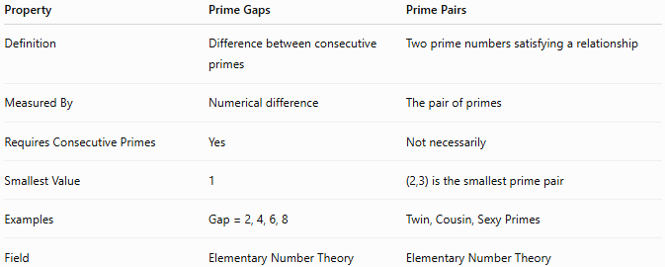
Property | Prime Gaps | Prime Pairs
Definition | Difference between consecutive primes | Two prime numbers satisfying a relationship
Measured By | Numerical difference | The pair of primes
Requires Consecutive Primes | Yes | Not necessarily
Smallest Value | 1 | (2,3) is the smallest prime pair
Examples | Gap = 2, 4, 6, 8 | Twin, Cousin, Sexy Primes
Field | Elementary Number Theory | Elementary Number Theory

Conclusion
# Source: AI Source: Provided by: [Data Path: Persons Table -> ID Column: 1, Name_En Column: Motasem Essam] -> From: [ChatGPT] on [7/13/2026]
A prime gap is the difference between two consecutive prime numbers and is a fundamental concept in elementary number theory. Prime gaps describe how closely or widely prime numbers are spaced along the number line. The smallest prime gap is 1, occurring only between 2 and 3, while all subsequent prime gaps are even. Prime gaps are closely connected to prime pairs and prime constellations and remain an active area of mathematical research, with many important questions about their behavior still unresolved.

